“Through Mem’ry’s Haze”
The Extraordinary Life of Dr. Charles Apel ‘69

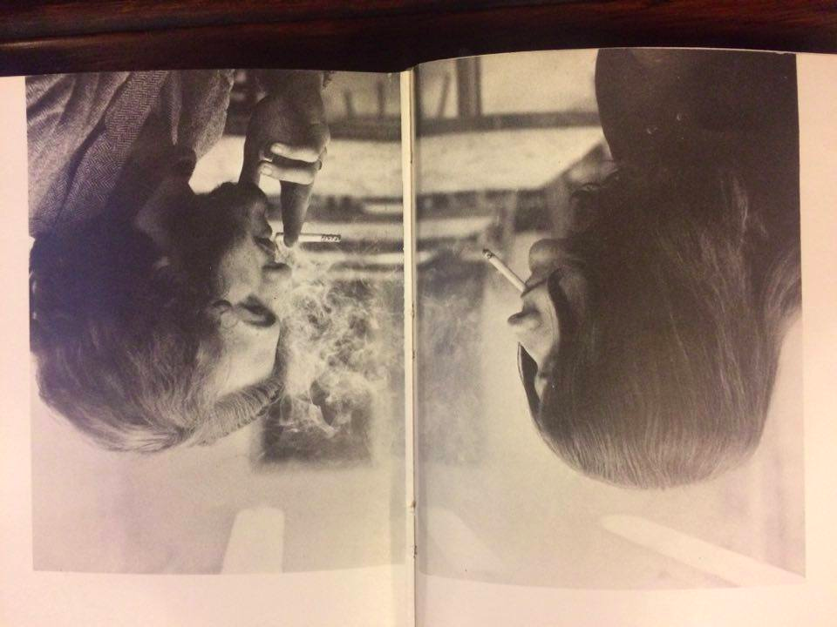
Charles Apel at Yale
(Spring 1967; Yale Class Book: 1968)

Graham Ambrose
GrahamAmbrose1@gmail.com

HIST 134: Yale & America
Professor Jay Gitlin
On Monday, March 6, 1967, Yalies woke up to a provocative missive printed in that morning’s Daily News: “The Marijuana Controversy in Perspective: I.” “Cannabis Sativa,” opened the op-ed, “one of the oldest domesticated plants known to man, has been used for thousands of years in the Orient and the Middle East…Today, with thousands of inquisitive college-age people using the drugs to explore the remote regions of their minds, marijuana has become the center of much heated controversy.” Indeed, the column appeared at a high point for consumption and consternation of the drug at universities like Yale. By addressing common questions – “Is marijuana addictive?”; “Is marijuana physically harmful?” – the author set out to authoritatively, comprehensively, and convincingly argue for the legalization of “pot” once and for all.
The intrepid student-writer was fifty years ahead of the mass movement to legalize recreational cannabis in the United States. His name was Charles Lawrence Apel, a sophomore in Jonathan Edwards College from Columbus, Ohio. More than a simple paean to marijuana, Apel’s columns in the Daily News testified to the personal evolution of the physics major over the course of two years at Yale—from a sober, Midwestern, math-loving college freshman in August of 1965 to a bohemian, rebellious, drug-addled child of the counterculture by April of 1967.
Just five weeks after the Daily News printed the two-part op-ed on marijuana, Apel would pack up his room in JE, board a Greyhound bus headed for the Pacific, and leave Yale for good. From New Haven, he began a circuitous lifelong journey in search of intellectual enlightenment, access to mind-expanding drugs, and personal refuge. He would wind up in San Francisco during the Summer of Love, living as a groupie of Jefferson Airplane and Jim Morrison; in the rainforest of Colombia during the early 70s, running from professional responsibility and legal jeopardy as a draft-dodger; in the golden hills of northern California, working through the 80s and 90s as a florist by day and a chemist immersed in the underground drug trade by night; and, by the early 2000s, back in the academy as a chemistry PhD, researching the origins of life at the National Aeronautics and Space Administration.
The remarkable life of Charles Apel, a Yale dropout-turned-hippie-expat-chemist, began in William Harkness Hall with a fateful D in German, the prologue to an exceptional and serpentine odyssey across national borders, careers, and physic states. His story – from Yale to jail, from sobriety to inebriety, from Columbus to Colombia, from a twenty-year-old Ivy League failure to a fifty-six-year-old newly-minted doctor of chemistry – reveals much about the institution, Yale, and its historic moment, the mid-1960s, that fundamentally altered the course of a life, nation, and world. Above all else, the tale of Charles Apel speaks to the timeless value of courageous individuality—a quality known intimately to the Yale graduate who never was. A representative vista into college campuses of the era, a unique account of one man at the center of a movement far greater than himself, the improbable narrative of Charles Lawrence Apel demonstrates how even the most unlikely individuals shape communities, interact with institutions, adapt to circumstances, and shake the very rudiments of history itself.

* * *

Charles Apel was born in Columbus, Ohio on March 22, 1947. A gifted student, by age 15 he had completed the requirements to graduate high school. Rather than send him to college early, though, his parents decided to keep him with his age group in the public school system. In the mornings, he busied himself with extracurriculars like choir. In the afternoons, he pursued higher-level math and physics classes, the subjects he loved, at Ohio State University, a flagship institution based nearby in Columbus.
After a few years living at home while studying among undergraduates, Apel itched to leave. The first in his family to even apply to college, he earned a perfect score on the SAT and received scholarships to MIT, Harvard, Stanford, Yale, and Colgate, a small liberal arts school tucked in the Catskill Mountains of upstate New York. “Colgate flew me out to tour the campus in the middle of winter. It looked like a bleak prison fortress in the middle of nowhere surrounded by six feet of snow,” Apel said. “Before I went home, I decided to check out the Yale campus and fell in love. Most people would agree it has to be one of the most attractive campuses anywhere.”
After one visit, Apel had made up his mind. He committed on the spot to enter the Yale class of 1969 as a freshman. By August of 1965, the eighteen-year old had moved into a double in Bingham Hall, the Jonathan Edwards College outpost for freshmen on Old Campus.
From his first day on campus, Apel felt like an outsider. Midwestern, middle-class, and the first of his family to attend college – let alone a two-hundred and sixty-four year old one brimming with children of alumni – Apel hailed from a background unrecognizable to his peers. Yale had only recently begun to pivot away from its reputation as the stomping-ground for the white, Anglo-Saxon, Protestant, New England elite. In fact, only in 1963, two years before Apel’s matriculation, had Yale admitted its first class in which the number of high school students equaled the number of prep school students. Harvard and Princeton had reached such parity in the 1940s and 50s, respectively.
“I didn't have any trouble making friends, but it was clear from the start that most of my classmates were from wealthy families and had gone to private boarding schools,” recalled Apel. “This was especially apparent when they all went home on holidays and I was there alone on the campus.” During high school and at Ohio State, Apel had forged community with peers through a shared love of learning. Suddenly far away from home, the culture-shocked freshman found Yale’s immense resources overwhelming. “I didn't know what I wanted to major in,” he recalled. “I felt like I was in a candy store looking at the catalogue.” With the sweet illusion of infinite choice came the sour debilitation of oversaturated options. In his first two years, Apel sampled the Blue Book’s staples and stars, including Vincent Scully’s introduction to architecture, visiting professor Margaret Mead’s course on social anthropology, and survey lectures on engineering.
To fulfill the language requirement and complement his interest in the sciences, Apel also enrolled in German, a decision that would alter the course of his life. “I hated it,” he said. “I had been a Latin scholar and was programming computers in high school. Any symbolic language was easy for me, but I never had an easy time with a new spoken language.” He nearly flunked, finishing the semester with a D. To salvage a moribund transcript, he realized he would have to retake the course over the summer. He decided to join a few friends from school in Cambridge and enroll in summer classes at Harvard.
Disillusioned with the stifling social scene dominated by New England preps and disheartened by an academic milieu that began presenting unforeseen challenges, Apel inadvertently found community among the “hip-artist-beatnik types” halfway through freshman year. The fellowship began when Apel first tried illicit substances in the early fall of 1965. It began with sips of alcohol at parties. By December, a freshman friend had introduced him to the study drug Dexedrine. “Definitely a gateway drug, at least for me,” Apel said. “I remember walking around campus in the middle of a snowy night thinking, ‘Wow! I want to feel like this all the time.’"

* * *

Apel was not the only contemporary student experimenting with substances on campus. The late sixties marked the zenith of drug culture at Yale. Over a period of three to four years from roughly 1964 to 1968, Yale engaged in the most earnest discussion on illegal substances in its history. Just a few years earlier, Yalies had scantly talked about non-alcoholic substances. A summary report on undergraduate behavior drafted by the Yale College Dean’s Office, “A Survey of Disciplinary Actions Undertaken by the Executive Committee of Yale Colleges and the Rules Committee of the Freshman Year: 1958 – 1963,” did not list a single offense related to drugs. By contrast, the report cited more than two-dozen disciplinary incidents related to alcohol.
Over that five-year interval between 1958 and 1963, marijuana received only six mentions in the Daily News. In the 1966-67 school year alone, when Charles Apel was a sophomore, the Yale Daily News printed an article, editorial, or op-ed related to drug use on average twice a week. In fact, the first editorial under Publisher Strobe Talbott, class of 1968, argued for Connecticut to revisit laws criminalizing marijuana. Instigated by campus coverage, national publications brought Yale’s internal debates on the counterculture to readers across the country. “Among Yale Men The Subject’s Pot,” read one headline of a timely New York Times piece probing the purported ubiquity of marijuana on campus. “There is general agreement,” the Times reported, “that the use of marijuana has increased tremendously in the last few years, as it has at most colleges.” Students estimated that between twenty and thirty percent of undergraduates had consumed cannabis while on campus. Yale College administrators, relying on data gathered by the Council of Masters in the spring of 1967, found that about one in five students had tried cannabis. The report found regular consumption of marijuana to be markedly lower, though, at only about 9% of the student body. Only 2% of students surveyed reported using LSD.
The ostensibly high number of drug users and flowering debate on cannabis did not signify Yale’s transformation into an oasis of free love and plentiful substances, though—nearly the opposite. As students like Charles Apel began experimenting and publically advocating for looser state, federal, and university regulations on drugs, the New Haven Police Department had begun cracking down on substance use at Yale. In the 1966-67 school year alone, town police officers conducted three drug busts in the residential colleges, arresting six Yale students. Off-campus raids in Greater New Haven nabbed dozens more, including Yale students and even University professors. The arrests generated scandals for the town and university, driving drug culture deep underground and setting off a wave of backlash against administrative compliance with state policies
In truth, university administrators knew little about the consequences and culture of drug use. Though generally permissive of non-violent behavior in private student residences, administrators allowed town police to bust students only out of simple deference to the law. Through the 1960s, the administration lagged conspicuously behind narcotics enforcement intel, even on its own turf. After an Associated Press report claimed that undercover Bureau of Drug Abuse Control investigators were working on American campuses to disrupt the sale of narcotics, Dean of Yale College Georges May and Security Director John Powell professed no knowledge of any clandestine activity—though they “could not, however, completely rule out the possibility of investigations at Yale…It was ‘quite possible’ that federal agents could be present without notifying University authorities.”
To collect qualitative and quantitative data on the topic, Yale administrators solicited two surveys of undergraduates – one on a gallimaufry of hallucinogens in February of 1967 and the other, in April of that year, specifically on marijuana. “This is a case of the halt leading the blind,” opened the subsequent “Drug Report” from the Council of Masters in May of 1967. At a meager seven pages, the document summarized the paucity of existing literature with insights that were progressive, both then and now. “Marihuana is not a narcotic…it has no [sic] detremental effect on physical health…it does not cause physical dependence.” Comparing smoking to drinking, the report conceded that alcohol empirically and circumstantially posed a greater harm to students. The document also dissembled stereotypes associated with pot, noting that “students who use the drug may come from any kind of background…The motivations for using marihuana are many and sometimes complex.” The Council speculated that such motivations included “use simply ‘for kicks,’” “separation from parental or other authoritarian control,” or “the appeal [of] that which always attends what is forbidden.” To varying degrees, all three fit Charles Apel.
Although the heads of residential colleges supported reforming stringent bans on pot, the Yale College Dean’s Office took a more apprehensive approach. Security Director and Associate Dean Powell represented the uncompromising voice against drugs in the administration. At a 1967 International Security Conference in Los Angeles, Powell, a hardline conservative, pilloried “un-American” students who upended campus rules and norms. “Powell called it ‘unfortunate’ that many college deans and faculty members just a few years out of college sympathize with student demands.” To circumvent more liberal members of the administration, “he suggested universities should hire experienced security officers, give them a ‘free hand’ in working with outside law enforcement agencies.”
A countervail to Powell’s ironclad condemnation of 60s youth culture, Dean May himself sympathized with students, including those who decried harsh drug laws. The Dean, though, ultimately had a responsibility to serve as Yale’s enforcement czar, and, despite personal misgivings, understood the university’s precarious position between quixotic student demands and abiding state and federal mandates. In a May 1967 letter to undergraduates, May recognized mounting frustrations while affirming university compliance with the law. “No amount of discussion about the appropriateness of the State Narcotics Law can detract from the hard fact that at the present time possession, use, or distribution of illegal drugs, including marijuana, make anyone involves with narcotics, even in a single experiment carried out in the privacy of one’s room, liable to arrest, conviction, fine, and imprisonment.”
Below the prevailing liberalness of campus, some students rallied around the anti-drug crusade. From the upheaval emerged the “God Squad,” a nine-member group of Christian fundamentalists that spread anti-hedonistic pamphlets, held secret meetings to discussing the state of students’ souls, and warned that “Satan is establishing a beachhead for narcotics at Yale now.” One member of the evangelical organization, Mark Wilson, class of 1969, confessed that drug use had thrust him into the embrace of the Christian God. “I was involved with marijuana and LSD,” he said, “and the effects were disastrous. After my LSD experience, I rejected all the petty values and games I had been playing. The barriers were broken down for me and I was thrown into the supernatural.” Though campus at-large took the God Squad less seriously than its fire-and-brimstone members, the group’s existence and longevity into the 1970s chronicled a chapter of the culture wars centered on drug use. By the late 60s, illicit substances at Yale had become a flashpoint for countercultural apostates and reactionary acolytes alike. “Perhaps Yale has helped us to fight these private wars,” wrote one contemporary in the 1967 Class Book. “More than likely it has simply let us fight them.”
Back in 1966, as the New England winter began to wrap Mother Yale in a white blanket of snow, freshman chemistry major Charles L. Apel unknowingly stood in the eye of a storm that would soon chart a new course for his life. Apel, who by January 1966 had only dabbled with alcohol and Dexedrine, eventually began experiments of his own with a new drug, marijuana. On Old Campus, far from the posh laboratories atop Science Hill, he was introduced to weed by an electric bass player who lived upstairs in Bingham, Apel quickly joined leagues with a clandestine cohort of freshmen who shared nickel bags of cheap supply. “We used to get high and listen to music,” he said. “Beatles and Stones, mostly. It was a small clique.”
By the end of his freshman year, Apel had strayed far from his innocent Midwestern upbringing, moving deeper and deeper into a circle of drug-addled artists who thrived in the shadows of the campus underground. Though hardly a bohemian yet, and still attendant to his studies, Apel had glimpsed, tasted, smelled, and heard the “high” life outside the ivory tower. Heading to Cambridge to redo German, Charles Apel stood at the gateway to a different life. It would take Harvard, though, to fatefully neuter the bulldog for good.

* * *

In the late spring of 1966, living out of a shared apartment near Central Square in Cambridge, Apel the Eli entered enemy territory as a temporary Cantab hoping to return to New Haven with a serviceable grade point average. What began as a faux-animosity – rooted in the longstanding rivalry between two titans of American history, education, culture, and civic life – had by the end of the summer morphed into a widening chasm between Apel and the academy itself. Eventually, that rift would grow into Apel’s full-scale rejection of conventions at the heart of American society.
In May, a few days before the first summer class, Apel’s roommates invited him to attend a lecture by Timothy Leary, an ex-Harvard psychologist who became a nationally-recognized advocate for and researcher of psychedelic drugs after being fired from the nation’s oldest university in 1963. Throughout the sixties, Leary, whom Daniel Yergin of the YDN described as a “self-appointed cult leader,” toured college campuses with a simple slogan: “turn on, tune in, drop out.” On May 22, 1966, the “high priest of the LSD cult” lectured a crowded Boston auditorium on the virtues of psychedelic drugs. The charismatic iconoclast wore a beaming smile, a gray suit fit for The Ed Sullivan Show, and a silver lapel pin, the insignia of his homemade religious organization the League of Spiritual Discovery.
Apel was enraptured. “I remember standing there before the lecture in a crowd, looking around, and all of a sudden I felt something,” he recalled. One line of Leary’s lingered: “I found that a university was not the place to expand consciousness.” The hypnotic figurehead of the counterculture appeared glad, even grateful, for his departure from the Ancient Eight. Charles Apel, already a heretic at Yale, had heard the holy orders from the mouth of the prophet himself.
After the lecture, waited for the spellbound audience to thin before approaching the forty-five year old visionary himself. “I stuck around and got invited over to his digs and took my first acid trip,” Apel said. “The only thing I had ever heard about it was what I saw in the newspapers: once you take it you go crazy and never come down, and that whenever you look in a mirror you will always see a monster,” he remembered. “I looked in the mirror that night and saw a very beautiful person. I decided then and there that this was the drug for me.”
The episode changed his life. By early June, Charles Apel stopped attending German class. Initiated into the society of psychedelia, he returned to Leary’s home and laboratory frequently over his stint in Boston, consuming LSD with the man who just three years earlier had been fired from Harvard on allegations of providing drugs to undergraduates—the very activity over which he and Apel had begun to bond. As the summer wound down, Leary took him aside and told him to drop out of school and meet him in San Francisco the following summer. “He said something very special was going to happen there.”
In the meantime, Apel returned to Yale. “I had no thoughts of dropping out of school at that point,” he recalled. Though once smitten by the counterculture, he could not forget what he had learned in Cambridge—all that Harvard and Yale had refused to teach him.

* * *

Back on campus, the 1966-67 school year soon devolved into drug-fueled shenanigans that increasingly landed Charles Apel and friends into trouble. The sophomore grew out his hair, took up vegetarianism, refused to attend mandatory physical education classes, and removed everything but a thin mattress from his room in Jonathan Edwards College. One particularly tense trial came in the fall of 1966, when a suitemate unknowingly consumed an LSD-based sugar cube left out in the common room freezer by a friend. The suitemate, a “really straight jock…totally freaked out.” A nervous peer called for an ambulance. Apel and his friend foresaw dire repercussions. “We were expecting the worst.”
A few days later, the two figured their reckoning had arrived when Beekman Cannon, Master of Jonathan Edwards College, summoned Apel and friend to his office. “He just laughed and told us that he had swallowed goldfish when he was an undergrad and that we should just stop our silly stuff.” Rather than punish the miscreants, “he told us not to mention the incident and we promised we would not.” Master Cannon had forged a gentleman’s agreement. “Beekman was not so much tolerant as he was dismissive,” Apel said. “It was ‘just a phase’ and not significant. He just didn’t want to be bothered; he didn’t have a clue.” The College would, for the time, cast a blind eye to Apel’s antics and drug habits.
Cannon’s response aligned with certain high-ranking administrators, like Dean May, and university leaders, like University Chaplain William Sloane Coffin. Yet, after hosting one particularly rowdy party – attended by William Scranton III, Yale class of 1969, son of then-Pennsylvania’s governor, and himself a future Lieutenant Governor of the state – Apel’s suite sat squarely in the crosshairs of New Haven police. According to Apel, Chaplain Coffin, informed by senior-ranking administrators, telephoned the suite to instruct the sophomores to hide their drug stashes indefinitely, in case of a raid. Apel’s story confirmed how drug users at Yale viewed the New Haven police, rather than Yale officers or administrators, as the greatest threats. Whether out of concern for the university’s reputation, for the specific students themselves, or out of kindred solidarity with the counterculture, Dean May, Master Cannon, and Chaplain Coffin balanced overarching legal obligations with efforts to shield students from the blunt of the criminal justice system. Although that ad hoc balance condemned some students to arrest by police, Charles Apel, his friends, and the some four-hundred other regulars smokers on campus benefited.
Still, Apel remembers only a few on campus sincere about the counterculture. “There were one or two at each college, and we knew them all,” he said. “Very little pot or psychedelics back then at all. Nobody even recognized the smell.” Instead, Apel and his acolytes found camaraderie in “faculty allies” like Sheldon Nodelman, a PhD candidate in the History of Art, who served as mentors, organized musical performances, provided outlets for discussion, and openly tolerated student use of pot and hallucinogens.
Undeterred by University laissez-faire and backed by friends and allies across the university, Apel slid away farther and farther from his academic interests into the counterculture. As a sophomore, he switched majors from physics to psychology—only to take classes from Assistant Professor of Psychology Michael Kahn, a “dear friend” of Leary and vocal advocate for academically-sanctioned used of LSD. Kahn provides a illuminating parallel to Apel. Kahn, also from Ohio, graduated from Harvard in 1948 after serving as a bomber pilot in the Second World War. He first gained familiarity with psychedelics as a subject of Leary’s inaugural LSD experiments. By the fall of 1966, Kahn had become Yale’s leading exponent of psychedelic culture. “He is a man who is uniquely turned on to life,” wrote a contemporary profile in the Yale Daily News. “A teacher [who] has the extraordinary ability to generate creative thought” Kahn proved more popular among students than faculty. In 1965, his colleagues voted to deny him tenure. “It has been pretty clear for a long time,” Kahn told the Daily News about the anti-psychedelic sentiment within the Department of Psychology. “I never seriously thought I would get tenure.”
Kahn and Apel would both exit Yale the following year, though by the dusk of 1966 only the former yet recognized his fate. Apel admired the man and attended his introductory survey, Psychology 10b, through that fall. In Kahn’s course, Apel met a musician named John Anderson, who in the summer of 1965 had begun playing bass with a raucous East Village rock band called The Fugs. Anderson encouraged Apel to join him in Manhattan for weekend shows at venues like The Astor Theatre, The Café Au Go-Go, and Café Wah. “I ended up taking the train in to New York City whenever I could and became part of the beatnik and art scene there,” Apel said. In the Village, he gained a tantalizing feel for the bohemian lifestyle Leary had promised the Yalie back in Cambridge.
On campus, the Ohio-born sophomore, who from the outset had felt like an outsider, grew more and more impatient with regal life in the gothic oasis. “It all seemed so contrived and phony. You had to wear a coat and tie to every meal, including breakfast,” he complained. “Meanwhile, the university was surrounded by a dangerous and impoverished ghetto of blacks, and we seldom ventured there. Physical education was necessary in order to graduate and they had arbitrary goals set that everyone had to pass.”
As winter bloomed to spring, he retreated irrevocably into the tight-knit community of bona fide hippies bonded by drug use, rock ‘n’ roll music, and contempt for war. That community grew tighter over the first weeks of 1967 in response to ongoing campus drug raids by the New Haven Police. Nervous about losing their peace and privacy, Apel decided to speak out publically. In January of 1967, he and a hippie-friend Stephen Record published a letter-to-the-editor in the Daily News lambasting the university’s treatment of three Yale students who were arrested by the NHPD on charges of consuming marijuana. “Somehow this entire affair leaves a lingering bad taste,” wrote Apel and Record:

“This may sound melodramatic, but quite possibly three persons’ lives have been ruined because of the possession of a drug less harmful and less addictive than either alcohol or tobacco. There exist strict laws controlling the consumption and distribution of alcohol, which are flagrantly disregarded on this campus as on many others. There is a wealth of well-documented evidence of the damaging effect of alcohol on the liver, and tobacco on the lungs. But these socially accepted intoxicants are spared the righteous wrath of mother Yale, which is leveled instead against the ‘narcotic’ marijuana.”

Their letter, in turn, prompted a string of responses in the Daily News. Sympathetic students directed the bulk of their ire at the university for supporting outdated narcotics laws that unduly harmed the accused. “The Yale administration is fighting a losing battle,” wrote one student from the class of 1969. “We seriously hope that the Yale administration catches up on their cultural lag and rejoins the Yale community.” Others channeled frustrations toward the state, denouncing Connecticut drug laws that “punished for purely private and harmless actions.”
That spring, Apel’s byline would appear three more times in the Daily News: once, in February, via another letter-to-the-editor co-written with Record; and twice again in his own op-eds on marijuana published on successive days in early March. The op-eds, which ran on March 6 and 7, presciently captured the sophomore’s take on campus dialogue and on the case for decriminalizing marijuana. Apel invoked patriotism (“George Washington raised the plant at Mount Vernon…and may have been the first person on the Old Campus to have possession of the drug as he quartered his troops there during the Revolutionary War”), cited medical research (“in the history of hemp smoking in the United States, no deaths due to overdose have ever been substantiated”), and grazed culture (“the marijuana smoker would rather sit quietly and listen to music or discuss important issues, than drive around in cars or go out to pick fights in the streets”) to support the legalization of “a drug more harmless than either tobacco or alcohol.” He concluded with an appeal to eschew the “stupidity and narrowness [of] thirty years ago…and not forget that these same laws, initiated by such unenlightened men exist today.” “Certainly,” he added, “these laws should be updated to take recent scientific evidence into account.”
Apel’s rational, didactic arguments for a more progressive approach to weed provoked the national medical community, which responded in turn with remarks in the YDN of their own. “Marijuana is an extremely dangerous agent,” wrote George C. Downing, Clinical Assistant Professor at Stanford’s School of Medicine. “If Apel and Record insist upon using it themselves, that is their business. It is to be hoped that the rest of the University community will not be misled by their naïve claims.”
By the spring of 1967, Apel had crossed the Rubicon. “My final semester at Yale, my studies were the last thing on my mind,” he recalled. “The more I got into pot, the less appeal drinking alcohol had for me.” A rejection of alcohol – what The New York Times described in February of 1967 as “the true Yale vice” – amounted to a repudiation of the undergraduate social scene. “Yale is noted for its alcoholism, and Yales have long been proud of it,” remarked one member of the class of 1969 in a Daily News op-ed. Apel, meanwhile, found students’ double standards on substances disheartening. “The more LSD I took,” he said, “the more bizarre the situation at Yale seemed to me.”
Soon, Apel altogether abandoned any pretense at formal academics. “A few of us took a class in ancient Chinese literature in translation,” he said with a laugh. “We would megadose on acid when we showed up for class and would refuse to sit in chairs, preferring to sit in lotus position on the floor instead. That poor professor. He didn't know what was happening.” The class, which had only six students at peak, began quickly dwindling through the spring semester of 1967. By March, according to Apel, one of the students had been busted for drugs; two, including Apel, were wanted for draft evasion; and all had told the professor, half in jest, of their intentions to drop out and join a monastery in Toronto.
The admission marked Apel’s first serious flirtation with leaving Yale altogether. The university community remained divided between permissive students and an ambivalent administration. By April, the New Haven Police Department’s crusade against drugs was in full swing. The administration stood by compliance, even as some figures like Coffin and residential college masters tried to spare students the brunt of enforcement by tipping off undergraduates about upcoming busts.
Apel, who benefited from benevolent forewarnings from Coffin and the tacit indifference of Master Cannon, was not spared pressure from above. As he remembers, in the spring of 1967 university administrators began to grow concerned about his poor academic performance and aberrant lifestyle. “They figured they would scare some sense into me by setting up a pre-induction Army physical for me. They told us to strip down to our shoes and underwear. I wasn't wearing underwear and I had Beatle boots on,” he recalled with a laugh. “That was it for me. I grabbed my pants and ran out the door.” At last, something in Charles Apel snapped. Having just turned twenty, he felt in the budding warmth of spring a burning desire to leave Yale for good.
Like Professor Kahn, Sheldon Nodelman, and John Anderson, Charles Apel would soon leave Yale for the west coast. Having learned to “turn on” and “tune in,” all that was left was to “drop out.” On April 11, 1967, a small, twenty-word ad appeared in the Yale Daily News: “MUST SELL: Smith Corona Electric Typewriter oversized carriage, electric carriage return, originally $250.00, will sell for $150.00. CHUCK APEL. 711 J.E.” Coincidentally, Apel’s parting statement appeared just a few short pages after coverage on the University’s plans for draft enlistment, on the recent antics of the God Squad, and on a Cornell professor’s call to modify marijuana laws.
“All in all,” Apel remembered, "I felt like California was calling.”

* * *

What was calling in California was the Summer of Love, a social phenomenon between April and September 1967 in which thousands of hippies, artists, and counterculturalists like Apel descended on the Haight-Ashbury neighborhood of San Francisco. As Timothy Leary had promised a year before, the summer of 1967 heralded an unparalleled outpouring of youth-driven creativity and peaceful political activity, from Jimi Hendrix to Janis Joplin, One Flew Over the Cuckoo’s Nest to the musical Hair.
And at its center stood Charles Apel, a twenty-year-old physics prodigy-cum-Yale dropout from Ohio. In April of 1967, with nothing more than a suitcase at his side, Apel boarded a California-bound Greyhound from New Haven to meet up with Leary at Lou Gottlieb’s Morningstar commune in Sonoma County. There, in an environ different than any he had ever conceived, he met the woman who would become his first wife. After a few weeks, when members of the commune expressed interest in relocating to Haight-Ashbury for the summer, Apel readily joined in. By early May, just two months after penning a two-part op-ed in the Yale Daily News extolling marijuana, Apel had become the “official joint-roller” for Jefferson Airplane, an internationally renowned rock band that typified the historic moment and youth movement. The sextet, which headlined the Monterey Pop Festival in June, connected with Apel through mutual friends of The Fugs he had met in the East Village. Living in a community of true bohemians, freely consuming drugs with friends and mentors, Apel thought he had found bliss. “I had a new girlfriend and a dream hippie job. I was living with the members of the Jefferson Airplane and rolling all their pot into joints for them,” he said. “In return, I got a beautiful place to stay at the mansion, all the pot I could smoke, and all the Owsley acid I could take and give away. I also got to sit on stage whenever they played.” Ironically, to help out his friend Tim Leary, in San Francisco Apel even picked up a new trade, one more academic than avant-garde: publishing. “I set up a publishing company called Level Press and published all Tim Leary's writing for him for a number of years,” he said. “As an inmate at San Quentin, he was allowed to receive copies of his books brought in by his lawyer if they were sealed directly from the publisher. I always made sure the bindings were saturated with the good stuff,” LSD.
The Summer of Love though quickly turned into an autumn of consequences.
By October, Apel had been convicted in a federal court for draft evasion. Over the following years, he hid from federal officials with friends in California until 1971 when, out of options, he decided to cease hiding permanently in America and move to Colombia, where he could explore hallucinogenic drugs unknown in North America. “I picked Colombia because I was interested in experiencing the magic mushrooms there.” In South America, Apel foresaw an intellectual adventure that would offer indefinite refuge while integrating his background in chemistry, engineering, and academic exploration. “At the time R. Gordon Wasson and other prominent mycologists were under the impression that psilocybin mushrooms could not be grown in captivity.” Having procured false documentation through friends back home at Kent State University, Apel fled the United States without knowing when he would return.
South America presented the adventure he had sought. For nearly seven years, Apel lived with his wife and children among the indigenous people of the Colombian rainforest for nearly seven years. When the Vietnam War ended, and President Carter pardoned draft-dodgers in January of 1977, Apel knew he could safely return home at last. In the late 70s, he moved back to the States to share what he had learned about Colombian psychedelics with an American audience more acrimonious to hallucinogens than a decade earlier. Still, Apel forged ahead. “I figured out how to propagate [mushrooms] while I was in Colombia, and when I returned to the States wrote a series of pamphlets on how to do it.” He published the results under a pseudonym in a series of informational booklets and magazines.
For years, Apel eked out a livelihood researching and selling hallucinogenic drugs in the black market of northern California, a tolerant haven of ex-hippies like himself who faced little legal or social scrutiny. His Yale credentials helped him win trust as a manufacturer and marketer of illicit drugs. “I admit that my association with Yale and friendship with my Harvard friend Tim Leary allowed me to move freely into those groups,” he said. “They trusted me knowing I was an intellectual, an idealist, a ‘believer’ and not so interested in the money end of things.” When the industry became too dangerous in the late 1980s, however, Apel “retired from the drug biz” and became a florist in Mill Valley, a quiet hamlet an hour north of San Francisco. In Marin County, he raised his family. In the spirit of Voltaire’s Candide, he set out to live simply and cultivate his garden.
For years, the income and relative peace offered a serene coda to a lifetime of racket-making. Over time, though, the nest egg began to enfeeble, and Apel, midway through life and intellectually active as ever, felt a sudden urge to return formally to his original passion: science. In the mid-90s, he went back to school in hopes of earning the degree he never received from Yale. He graduated from the University of California-Santa Cruz with a Bachelor of Arts in 1999 and a PhD in biochemistry in 2003. From September of 2003 to his retirement in 2014, he worked in astrochemistry at NASA as a National Research Council postdoctoral fellow. He also researched the origins of life at the Search for Extraterrestrial Intelligence Institute, publishing influential papers on astrobiology and the inception of life on Earth. At age sixty, Apel began teaching biochemistry at San Jose State, briefly entertaining the idea of taking a tenure-track position. Ironically, after a forty year hiatus, Charles Apel had become the very ivory-tower academic he admired in Michael Kahn and scorned in Beekman Cannon. He had, four decades later, fulfilled his boyhood dream.
Today, Apel spends his time in Sunnyvale, California, consuming cannabis and hallucinogenic acid; making music with his “hypno-trance” band The Guru Daddies; spending time with his wife, seven children, and fourteen grandchildren, and selling homegrown medicinal marijuana, particularly strains with anti-cancer properties. His medicinal marijuana products, marketed jocularly as “Dr. Apple’s Vegetarian Snake Oil,” promise far-ranging health benefits without psychotropic effects. “Yes, in the end,” Apel said with a laugh, “I may finally be remembered as the hippie who took the ‘high’ out of pot.”

* * *

“I've had a very exciting life,” ruminates Charles L. Apel, who will turn seventy in March of 2017. After a lifetime spent hopping between continents, professions, and psychic states, he cannot help but feel pings of nostalgia. “I look back at my time at Yale with a great deal of fondness, and often wonder what would have happened if I had continued there instead of dropping out of the physics program.” Apel wastes little time consumed with the counterfactual. From what he has seen and done, a few morals emerge from “mem’ry’s haze, those happy, golden, bygone days.” “I would certainly not recommend that anyone ‘follow in my footsteps,’” he advises. “The things I managed to pull off years ago would be impossibly dangerous to attempt now.”
By numbers alone, few modern Yalies do walk the Apel path. According to the Office of Institutional Research, roughly ninety-seven percent of incoming freshmen go on to earn a degree from Yale. Dropping out is sacrilegious. To some, today’s Ivy Leaguers more closely resemble “excellent sheep” than the rebellious and recalcitrant wolves of the 60s academy Apel attended. Indeed, on a postmodernist campus fixated upon systems, structures, institutions, and a deterministic worldview that diminishes the role of individual agency in the unfolding drama of history, Charles Apel’s remarkable life seems an impossible relic of Old Yale, a place where “great men” allegedly shaped affairs by singular dint of will.
Apel himself takes full responsibility for the past—its messy mistakes, improbable turns, and unexpected triumphs. “I think if there is one lesson to learn here,” he said wistfully, “it’s that the main course of my life was determined by personal decisions that I made when I was only twenty years old.” Indeed Charles L. Apel serves as a living testament to the endurance of human agency, reminding all Yalies – past, present, and future – that choices matter, that individuals can influence events, and that history is written not by the dead, but by the living.
Such framing locates Charles Apel’s story within a long line of Elis who have dissented against alma mater – from Jonathan Edwards, class of 1720, to Bill Buckley, class of 1950. What Apel lacks, what the more famous Yale rebels have, is a written opus of his own—at least, so far. “People tell me every day I should write my memoirs,” he said. “Maybe I will. At least you got me started thinking about it.”

Appendix

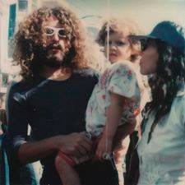
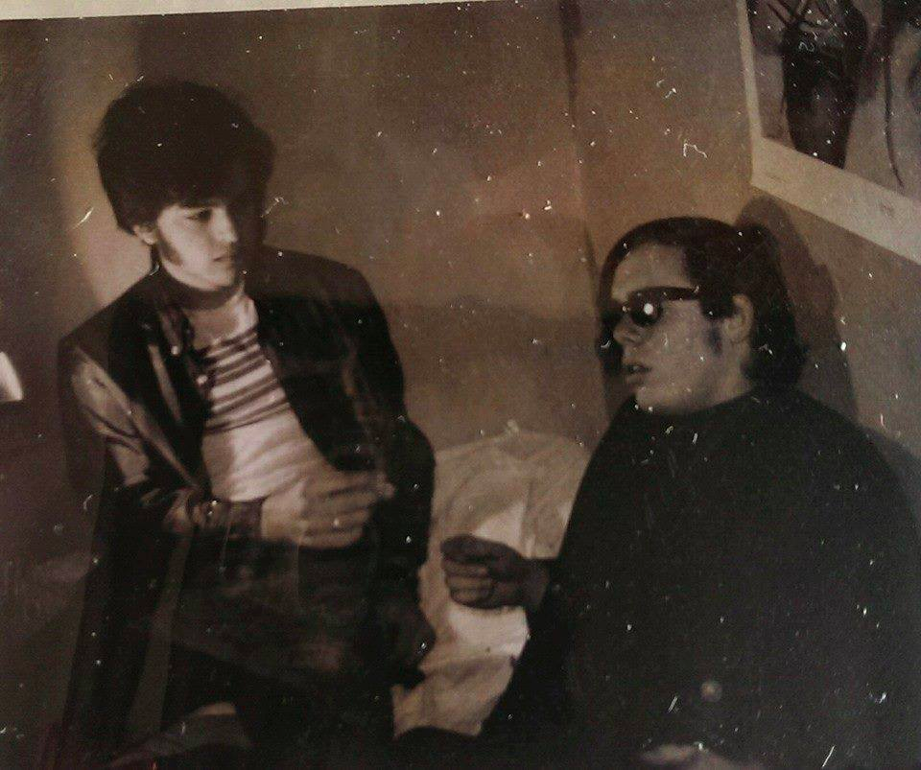
Apel and daughter, c. 1980
Apel and friend smoking marijuana in Jonathan Edwards College, fall 1966
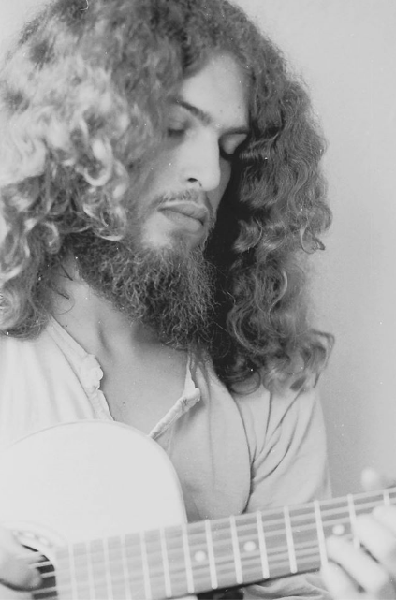
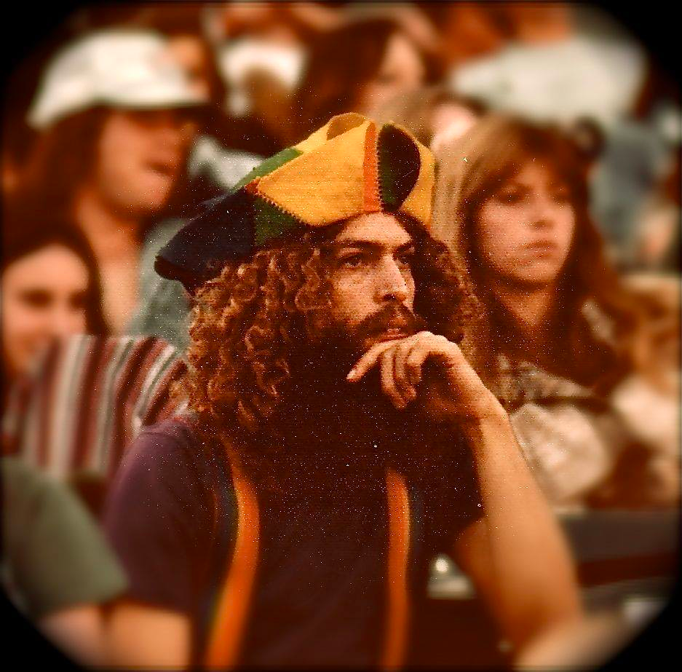
Apel on the road with the Grateful Dead, 1980
Apel playing guitar, c. 1978
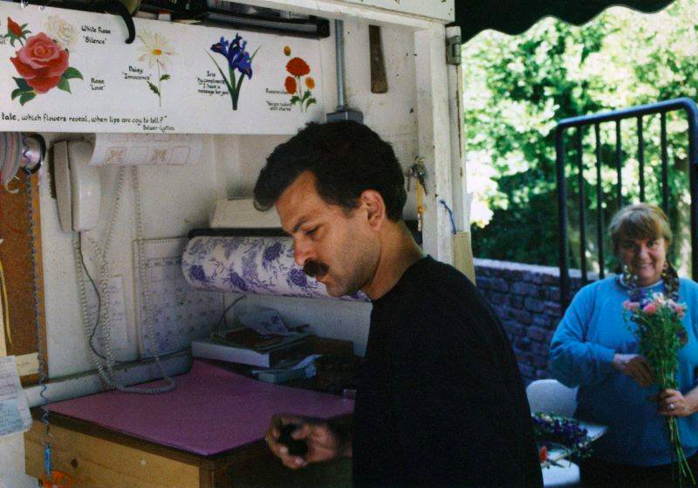
Apel and wife at the Mill Valley floral shop, 1994

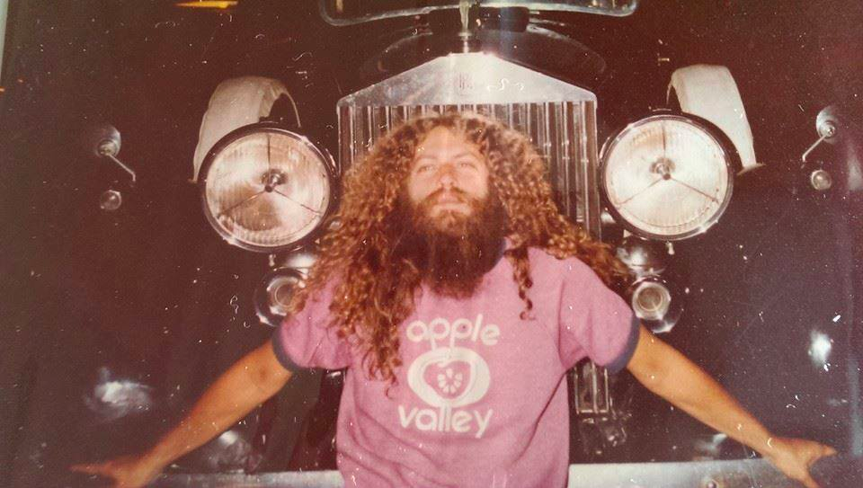
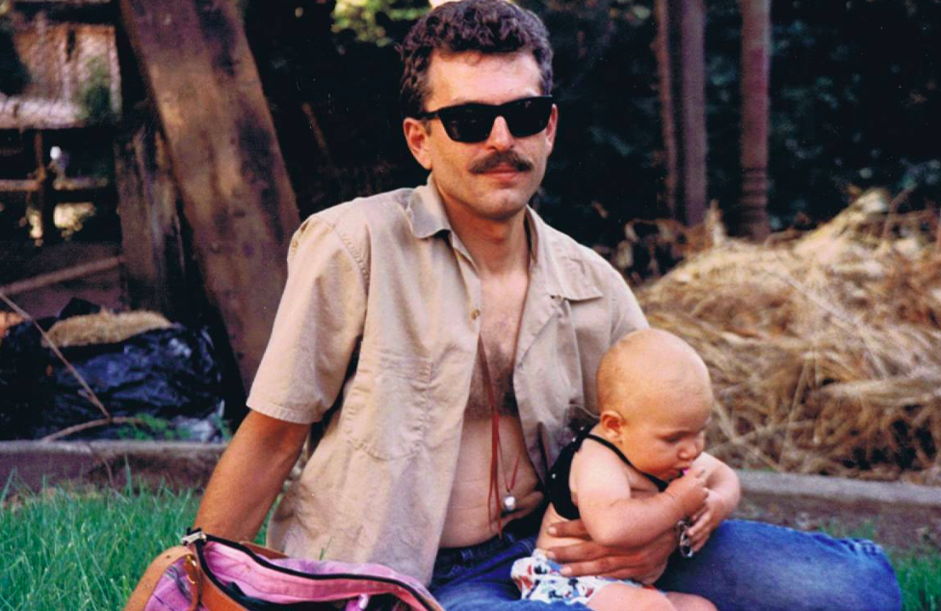
Apel, c. 1985
Apel and child, c. 1991
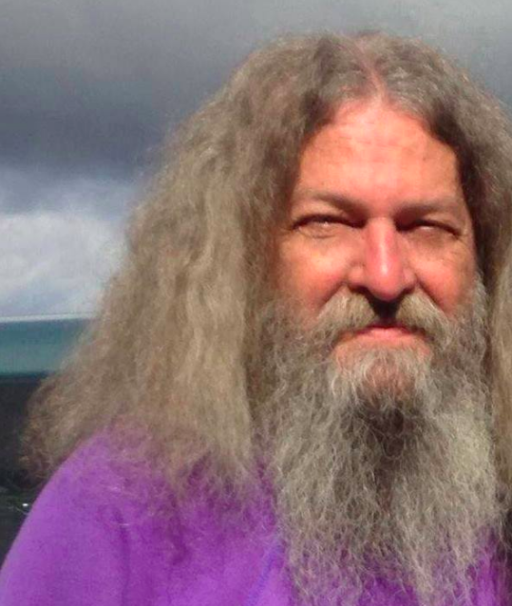
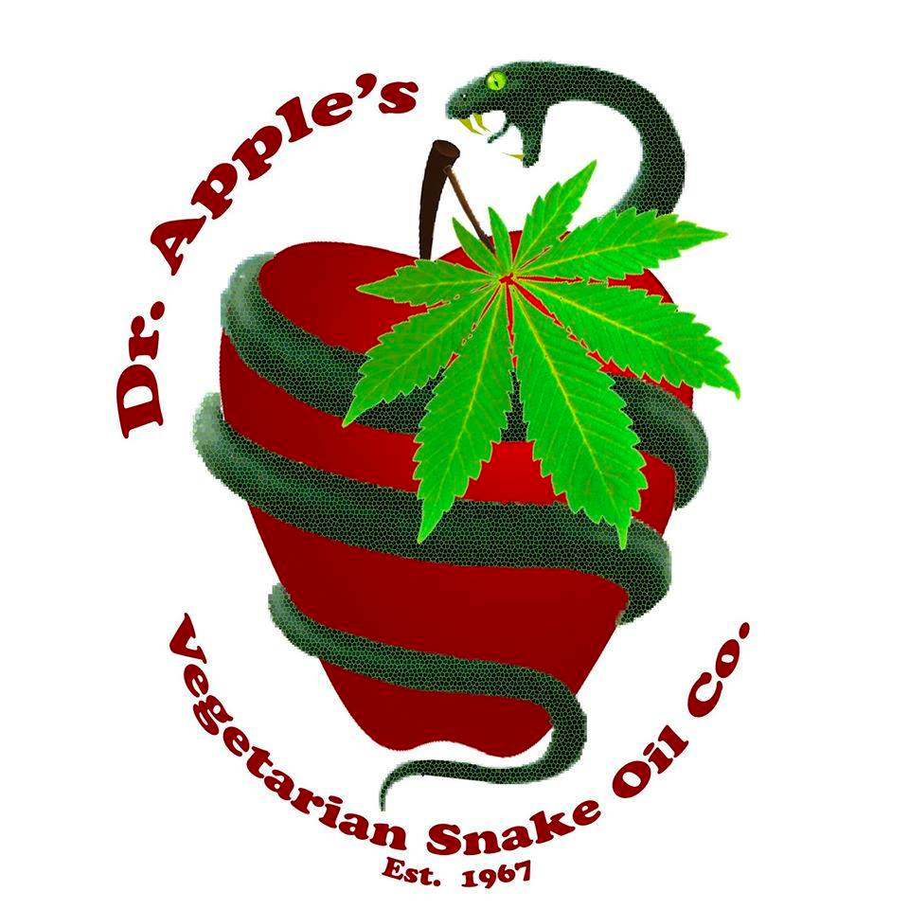
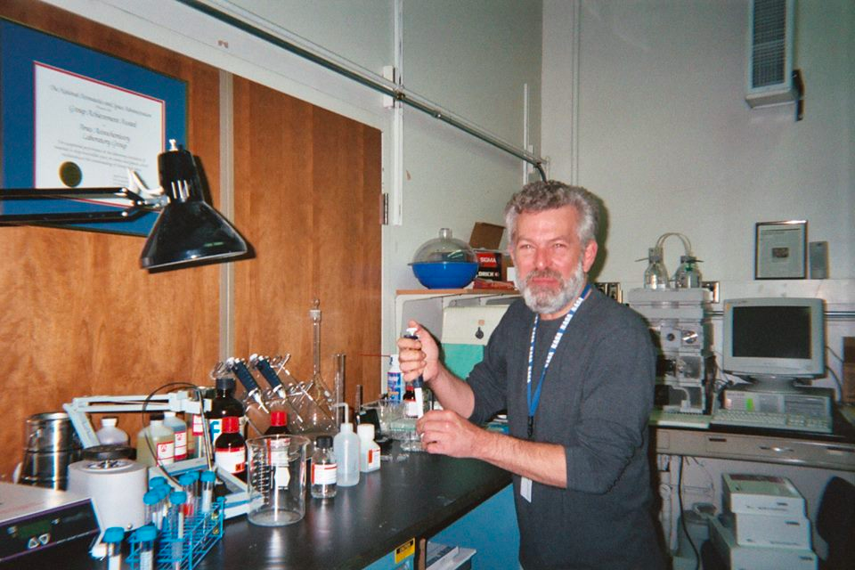
Apel’s homemade medicinal marijuana brand – “Dr. Apple’s Vegetarian Snake Oil Co.”
Charles Apel, 2014
Dr. Apel in his lab at NASA Ames Research Center, 2007

Ibid.
Ibid.
Charles Apel, “The Marijuana Controversy in Perspective: I,” Yale Daily News, March 7, 1967, 2.
Charles Apel, “Charles L. Apel,” Facebook.com, last accessed December 3, 2016, https://www.facebook.com/profile.php?id=100008235136094&fref=ts.
Charles Apel, email message to author, November 16, 2016.
Ibid.
Ibid.
Ibid.
Ibid.
Geoffrey Kabaservice, “The Birth of a New Institution: How two Yale presidents and their admissions directors tore up the “old blueprint” to create a modern Yale,” Yale Alumni Magazine, December 1999, http://archives.yalealumnimagazine.com/issues/99_12/admissions.html.
Ibid.
Charles Apel, email message to author, November 16, 2016.
Ibid.
Charles Apel, email message to author, November 16, 2016.
William Herman, “Mead, ‘Speaking Personally,’ Discusses Boas, Bombs, Birth,” Yale Daily News, November 11, 1966, 1.
Charles Apel, email message to author, November 16, 2016.
Ibid.
Ibid.
Ibid.
Apel shared a campus with many students who would become powerful and influential: John Kerry (JE ’66); Fred Smith (JE ’66), founder of FedEx; Joe Lieberman (YC ’64; YLS ’67); George Pataki (PC ’67); George W. Bush (DC ’68); Strobe Talbott (YC ’68), who edited the YDN when Apel wrote; Stephen Schwarzman (YC ’69); and Calvin Hill (YC ’69).
Indeed the Class Book of 1968 confirmed the rancorous revelry of campus in the late 60s. “We did more at Yale than just party. We sat around and tried to discover the meaning of all our partying,” one student wrote. “We came up with a myriad of ideas and rationalizations for the partying and then for a while we cursed Yale for not letting us do more of it.”
“A Survey of Disciplinary Actions Undertaken by the Executive Committee of Yale Colleges and the Rules Committee of the Freshman Year: 1958 – 1963,” RU 126, Box 27, Folder 350, Guide to the Yale College Records of the Dean, Accession 1980-A-017, Records of Georges May as Dean, Yale College Executive Committee and Rules Committee of the Freshman Year, Sterling Memorial Library, Yale University, 1963.
“Yale Daily News Historical Archive,” Yale University Library (1958-68), last accessed December 17, 2016, http://web.library.yale.edu/digital-collections/yale-daily-news-historical-archive
Editorial Board of the Yale Daily News, “Marijuana and the Law,” Yale Daily News, January 25, 1967, 2.
John Kifner, “Among Yale Men the Subject’s Pot,” The New York Times, February 28, 1967, 39.
Ibid.
Steve Kezerian, “Yale University News Bulletin,” RU 126, Box 27, Folder 350, Guide to the Yale College Records of the Dean, Accession 1980-A-017, Records of Georges May as Dean, Yale University News Bureau, Sterling Memorial Library, Yale University, May 12, 1967.
It is worth positing that the true rate of drug consumption might be higher than reported in the surveys. Drug users, fearing retaliation or intervention, might have underestimated use or simply not have filled out the survey at all.
“Drug Report: 1967,” RU 295, Series II: Subject Files, Box 19, Folder 41, Council of Masters, Sterling Memorial Library, Yale University, May 11, 1967.
John G. Brim, “Students Arrested on Marijuana Charge,” Yale Daily News, December 13, 1966, 1.
“Freshman Arrested in Yale Drug Raid,” Yale Daily News, April 28, 1967, 1.
Douglas Woodlock, “Police Arrest Trumbull Junior in Drug Raid,” Yale Daily News, April 20, 1967, 1.
Alan Levin and Douglas Woodlock, “Yale Instructor Nabbed on Drugs,” Yale Daily News, April 3, 1967, 1.
“Drug Report: 1967,” Council of Masters, 1.
Drug Crackdown: Narcotics Agents at Yale? Officials Uncertain,” Yale Daily News, February 6, 1967, 1.
“Drug Report: 1967,” Council of Masters, 1.
Ibid., 2-3.
Ibid., 6.
Ibid.
Ibid.
Ibid.
One parenthetical remark at the end of the report astutely captured Apel and his friend group: “(Interestingly enough, there are some reports that marihuana cliques are often less interested in alcoholic consumption than are ‘normal’ college groups.)” Apel confirmed that he and his “marihuana clique” seldom drank at Yale after earnestly falling in with weed.
“Powell: Colleges Require Expanded Police Force,” Yale Daily News, February 24, 1967, 1.
Ibid.
The Associated Press, “Georges May, 82, Yale Scholar and Provost,” The New York Times, March 9, 2003, http://www.nytimes.com/2003/03/09/us/georges-may-82-yale-scholar-and-provost.html.
Georges May, “Letter of May 2, 1967,” Yale College Dean’s Office, RU 126, Box 27, Folder 350, Guide to the Yale College Records of the Dean, Accession 1980-A-017, Records of Georges May as Dean, Sterling Memorial Library, Yale University, May 2, 1967.
One member of the God Squad, Robert T. Bakker, would go on to achieve significant fame as an academic. Considered one of the most important paleontologists of the twentieth century, Bakker earned a PhD from Harvard, inaugurated the “dinosaur renaissance” of the 1970s and 80s, and advised the creators of the blockbuster film Jurassic Park.
Kifner, “Among Yale Men the Subject’s Pot,” February 28, 1967.
“God Squad Takes to Song to Woo Yale’s Wicked,” Yale Daily News, March 3, 1967, 1.
Robert T. Bakker et al., “Letter: Caution on Pot,” Yale Daily News, February 22, 1967, 2.
H. William Hilgendorf, “Senior Year,” Yale Class Book: 1967 (New Haven: Yale University Press, 1967), 63.
Charles Apel, email message to author, November 16, 2016.
Ibid.
Charles Apel, email message to author, November 16, 2016.
Daniel Yergin, “LSD and Magazines,” Yale Daily News, June 1, 1966, 1.
“Leary to Disciples: Turn On, Drop Out,” Boston Globe, May 22, 1966, 17.
Charles Apel, email message to author, November 16, 2016.
“Leary to Disciples,” Boston Globe, May 22, 1966.
Charles Apel, email message to author, November 16, 2016.
Ibid.
“Leary to Disciples, Boston Globe, May 22, 1966.
Charles Apel, email message to author, November 16, 2016.
Charles Apel, email message to author, December 9, 2016.
Charles Apel, email message to author, November 16, 2016.
Charles Apel, email message to author, November 16, 2016.
Charles Apel, email message to author, November 16, 2016.
Ibid.
Charles Apel, email message to author, November 18, 2016.
Interestingly, though Coffin himself did not publically weigh in on the question of marijuana, the Associate Chaplain of the University, David M. Byers, published a column in the Daily News on February 14, 1967, arguing for a more enlightened view on marijuana. “My personal conclusion, at this point,” Byers wrote, “is that moderate use is not of such risk as to argue against its use entirely…but one must decide for oneself” (2). The Chaplain’s Office shaped debate on drugs through mouthpieces other than Chaplain Coffin himself.
Charles Apel, email message to author, November 17, 2016.
According to a 1999 article in the Pittsburgh Post-Gazette, Scranton III lost the 1986 election for Pennsylvania governor after his rival ran a television ad that evoked images of a pot-smoking hippie. Though Scranton insists the association did not decide the outcome, his admission to experimenting with drugs in college at Yale did prove a formidable issue in the campaign. http://old.post-gazette.com/regionstate/19990829drugs7.asp
“Getting High on Marijuana Issue,” Pittsburgh Post-Gazette, November 28, 1987, 4.
Charles Apel, email message to author, November 16, 2016.
Ronald Richenburg and E.J. Wasserman, “Letters to the News: Absurd Law; Distressed and Disgusted,” Yale Daily News, December 15, 1966.
“Drug Report: 1967,” Council of Masters.
Charles Apel, email message to author, November 17, 2016.
Ibid.
Andrew P. Garvin, “Mike Kahn Leaving Yale: A Man Turned on to Life,” Yale Daily News, October 28, 1966, 7.
Ibid., 1.
Ibid.
Ibid.
Interestingly, at the very moment Yale spurned psychological research on the effects of drugs, the university had already begun to bolster support for the sciences—the Daily News profile of departing-Assistant Professor Kahn appeared alongside an article detailing the dedication ceremony to the newly-opened $12 million, 14-story Kline Tower.
Ibid.
Ibid., 3.
Anderson, who temporarily dropped out of Yale after his sophomore year, would in 1967 be drafted into military service in Vietnam. Despite The Fugs’ famous anti-war advocacy, Anderson joined the fight to contain communism in Asia. He later returned to the States, graduated from Harvard Law School, and moved to an island off the Oregon coast (http://www.allmusic.com/artist/john-anderson-mn0001955288).
Ed Sanders, Fug You: An Informal History of the Peace Eye Bookstore, the Fuck You Press, the Fugs, and Counterculture in the Lower East Side (Boston: Da Capo Press, 2011), 150.
David Freeman, “The Fugs: Talking Dirty,” Yale Daily News, February 24, 1967, 5.
Charles Apel, email message to author, November 16, 2016.
Charles Apel, email message to author, November 17, 2016.
Charles Apel and Stephen Record, “Lingering Bad Taste,” Yale Daily News, January 10, 1967, 2.
Thomas J. Gillooly, et al., “Three Letters to the News on Marijuana,” Yale Daily News, January 30, 1967, 2.
Robert S. Withers, “Pot at Yale,” Yale Daily News, January 30, 1967, 2.
Richard Van Wagenen, “The Ivory Tower,” Yale Daily News, January 6, 1967, 2.
Charles Apel, “The Marijuana Controversy in Perspective: I,” Yale Daily News, March 6, 1967, 2.
Ibid.
Ibid.
Charles Apel, “The Marijuana Controversy in Perspective: II,” Yale Daily News, March 7, 1967, 2.
Ibid.
George C. Downing, “‘Naïve Claims,” Yale Daily News, January 30, 1967, 2.
Charles Apel, email message to author, November 16, 2016.
Kifner, “Among Yale Men the Subject’s Pot,” February 28, 1967.
Withers, “Pot at Yale,” January 30, 1967.
Charles Apel, email message to author, November 16, 2016.
Charles Apel, email message to author, November 16, 2016.
Ibid.
Though not common, dropping out of Yale was more frequent in Apel’s day. The 1968 Class Book estimated that roughly fifteen percent of Jonathan Edwards College students dropped out over their four years in New Haven.
“Counselors Warn Freshmen of Possible Drug Crackdown,” Yale Daily News, March 14, 1967, 1.
Charles Apel, email message to author, November 16, 2016.
Apel would actually reappear on campus a year after he dropped out—albeit, in a photo essay in the Yale Class Book: 1968. Without his knowledge or permission, Apel and friends appeared in a photo essay, “Mary Jane and Other People” (66-69), that showed the students smoking marijuana. Indeed, even contemporaries regarded Apel as a prototypical drug users on campus.
By the 70s, Nodelman would be employed as an Art Historian at the University of California-San Diego.
“Want Ads,” Yale Daily News, April 11, 1967, 5.
Michael A. Baris, “Army Secretary, Students to Discuss Draft System,” Yale Daily News, April 11, 1967, 1.
Timothy Bates, “God Squad Airs ‘Judgment,’” Yale Daily News, April 11, 1967, 1.
“Marijuana Law Change Called For,” Yale Daily News, April 11, 1967, 3.
Charles Apel, email message to author, November 16, 2016.
Charles Apel, email message to author, December 9, 2016.
Charles Apel, Facebook message to the author, November 16, 2016.
Charles Apel, email message to author, November 16, 2016.
Ibid.
Charles Apel, email message to author, November 17, 2016.
Ibid.
Charles Apel, email message to author, November 17, 2016.
Andrew Glass, “Carter Pardons Draft Dodgers Jan. 21, 1977,” Politico, January 21, 2008, http://www.politico.com/story/2008/01/carter-pardons-draft-dodgers-jan-21-1977-007974.
Charles Apel, email message to author, November 17, 2016.
Ibid.
Ibid.
Voltaire, Candide (New York: Boni And Liveright, Inc., 1918), 169, accessed via Project Gutenberg, http://www.gutenberg.org/files/19942/19942-h/19942-h.htm.
Charles Apel to Mike Folz, March 2007, in Yale Alumni Magazine, Vol. LXX, No. 4, March-April 2007, 114-5.
“Charles Apel: NASA Ames Research Center,” NASA Astrobiology Institute, last updated December 18, 2016, https://nai.nasa.gov/directory/apel-charles/.
Charles L. Apel et al., “Self-assembled vesicles of monocarboxylic acids and alcohols: conditions for stability and for the encapsulation of biopolymers,” Biochimica et Biophysica Acta (2001), http://www.academia.edu/18036633/Self-assembled_vesicles_of_monocarboxylic_acids_and_alcohols_conditions_for_stability_and_for_the_encapsulation_of_biopolymers.
“SK3 Group to Acquire Major Medical Cannabis Research Firm,” Yahoo! Finance, April 29, 2013, http://finance.yahoo.com/news/sk3-group-acquire-major-medical-141537134.html.
Charles Apel to Mike Folz, March 2007, in Yale Alumni Magazine, March-April 2007, 115.
Charles Apel, email message to author, November 18, 2016.
Charles Apel, email message to author, November 16, 2016.
Charles Apel, email message to author, November 17, 2016.
Charles Apel, email message to author, November 16, 2016.
Charles Apel to Mike Folz, March 2007, in Yale Alumni Magazine, March-April 2007, 114.
Henry Durand and Carl Wilhelm, “Bright College Years,” 1881, http://www.songsofyale.com/b.
Charles Apel, email message to author, November 18, 2016.
“Graduation Rates 2015-16,” Yale Office of Institutional Research, 2016, https://oir.yale.edu/sites/default/files/ipeds_grad_rates_data.2015-16.pdf.
William Deresiewicz, Excellent Sheep: The Miseducation of the American Elite and the Way to a Meaningful Life (First Free Press, 2014).
Charles Apel, email message to author, November 18, 2016.
Ibid.

