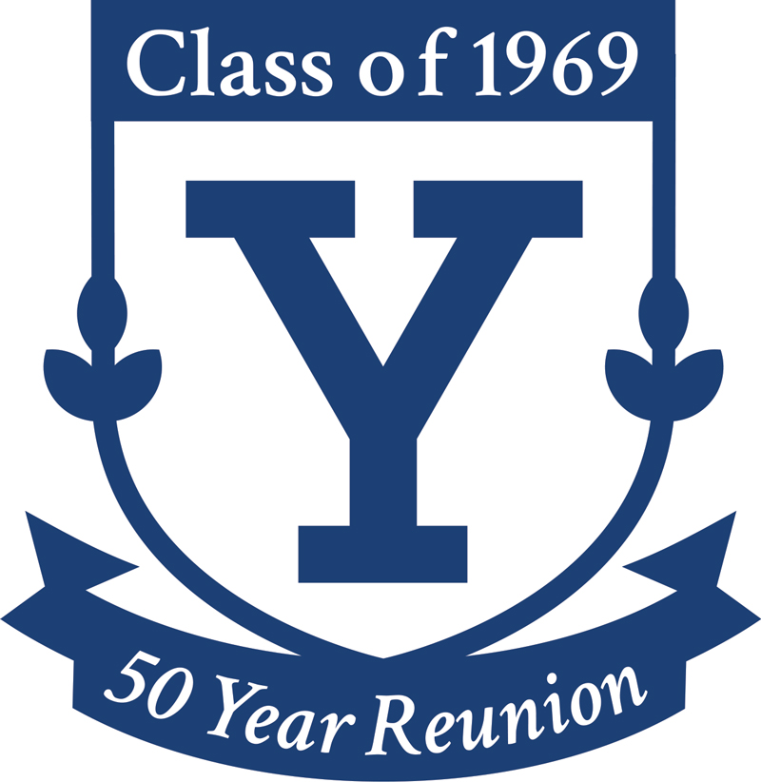 | Yale Class of 1969  50th Reunion Classbook  “Objective Data” Form

Your entry in the ClassBook will have your name at the top, then an optional block of any “Objective Data” you submit here, followed by the body of your Essay. The Objective Data block is meant to give the reader quick access to any contact information, family status and/or career highlights that you wish to share. The Essay itself is meant to be a reflection on your life so far. See http://yale1969.org/50-essays for more information. See examples of how it will look when published.
Don’t let the size of the blank deter you from longer entries; we’ll fix everything when we do page layout.
NAME: Your full formal name
CONTACT INFORMATION Your contact info (optional) for the ClassBook. See examples.
Email Use ‘permanent’ email address.)
Phone(s) Preferably your mobile number.
Address 1
Address 2
City, State, ZIP/Code Country

OTHER DATA [This information (optional) will appear in the ClassBook. See examples.]
Spouse/Partner(s) List name(s) & date/duration of marriage(s)
Child(ren) List name(s) and dates/years of birth
Grandchild(ren) List name(s) and dates/years of birth
Education List institutions, degrees and dates
National Service List branch & dates, e.g., Lt., US Army, 69-73
Career List key elements of career; < 50 words please
Honors List significant honors or awards; < 50 words
Activities List hobbies, avocations, etc.
Residential College Specify your college

